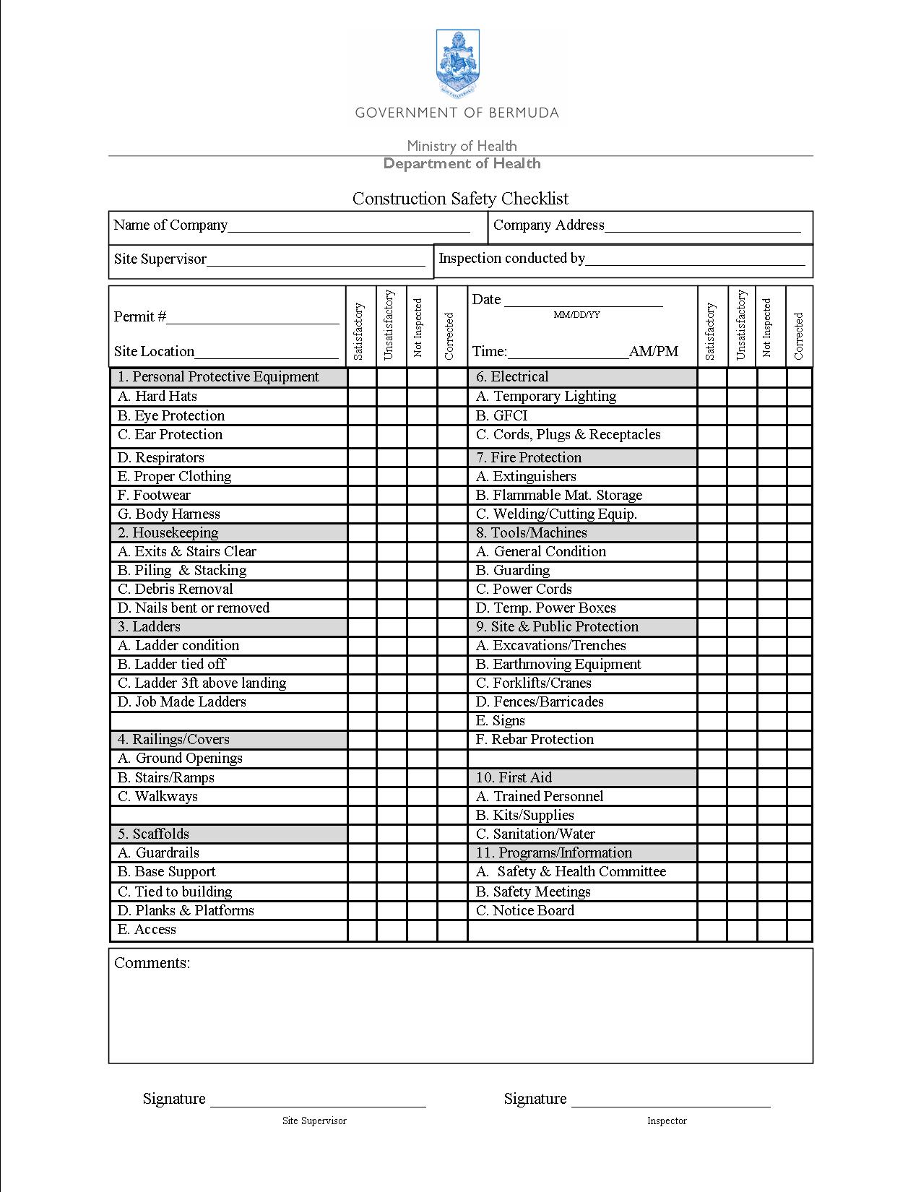
Construction Safety Checklist
Guidance notes

1. Personal Protective Equipment (PPE)
*Personal protective equipment (e.g. safety helmet, safety shoes, eye protection, etc.) must be used when the hazard cannot be eliminated.
2. Housekeeping
General Requirements: Employers have a duty to provide conditions that promote safety and health. This means:
- Keeping work areas, passage-ways, and stairs around project clear of scrap lumber and form lumber with nails.
- Remove garbage, combustible scrap, and debris at regular intervals during the day.
- Building materials should be stacked and stored safely to prevent collapse which could injure an employee.
3. Ladder & Stairs
(A) Ladder condition: look to see if feet are present, all rungs present, and free of
oil or grease that could be a slip/fall hazard.
(B) If ladder is not on stable or level surfaces it should be tied to prevent
accidental movement.
(C) Ladder (other than stepladders) must extend at least 3 ft above a safe
landing.
(E) Job made ladders: Should be able to support 250 lbs, rungs evenly spaced
(10- 14 inches), Ask your self, “Would I feel safe climbing this ladder?”
4. Rails/Covers
(A) Perimeter: Workers must be protected from potential falls greater than 6 ft.
Employer can choose to use guardrails, fall arrest or fall restraint.
(B) Ground Openings (e.g. water tank, cesspit, etc.) must be guarded to eliminate
fall hazards .
(C) Stairs/Ramps; Guardrails needed on all stairs/ramps with fall hazard greater
than 6ft.
5. Scaffolds
Note: Any employee working from a height greater than 6 ft must be protected from
falling.
- Guardrails: Should include a top rail (between 38 – 46 inches in height), mid rail (midway between top rail and floor of platform, and toe boards (at least 6 inches above the floor of the platform).
- Base Support: Scaffold legs should be supported on base plates and mudsills. Objects such as concrete blocks, scrap pieces of wood or buckets, should not be used as base support.
- Tied to building: Scaffolds with a height to base width ratio greater than 3:1 should be restrained from tipping by tying or bracing. (e.g. narrowest base width x 3 = max. height scaffold can be without being tied or braced).
- Planks & Platforms: Working platforms should be at least 18 inches wide and fully planked to prevent workers from falling between work platforms.
- Access: Proper stairway or ladder should be provided. No climbing on cross braces.

6. Electrical
- Ground-fault circuit-interrupters (GFCI): All electrical receptacles not part of the permanent wiring of a building should be GFCI. These devices are designed to automatically shut off the flow of electricity in the event of a ground-fault in a wiring system. The ground fault is the most common form of electrical hazard for construction workers.
- Cords, Plugs & Receptacles: Identify hazards such as exposed electrical parts, defective insulation, wet conditions, overloaded circuits, improper grounding (e.g. grounding pin removed from tool plug).
7. Fire Protection
Note: Materials commonly stored at a jobsite that are potential fuels for fire include
wood products (e.g. lumber), flammable liquids (e.g. gasoline), and compressed gasses (e.g. used for welding, cutting, and brazing).
(A) Extinguishers: Due to the variety in potential fuel materials found on
construction sites, fire extinguishers on jobsite should be classified as ABC
extinguishers.
(B) Flammable Mat. Storage: Flammable materials (e.g. gasoline) should be
stored in a well ventilated area that is clean and free of combustible materials
(e.g. paper, wood, etc.) Compressed gas cylinders should be stored upright
and secured to prevent cylinder from being knocked down or damaged.
(C) Welding/Cutting Equip: Routinely inspect and maintain welding equipment
and welding cylinders. Inspect cylinders regularly to make sure all parts are
in good working order (e.g. manifolds, headers, regulators, torches, and hose).
8. Tools & Machines
(A) General Condition: Tools should be properly maintained (e.g. oiling,
sharpening, storage). Are wooden handle tools (e.g. hammer, axe) loose,
splintered, or cracked? Are impact tools (e.g. chisels, wedges) found with
mushroom heads? Are workers using dull cutting tools?
(B) Guarding: Hazardous moving parts (e.g. belts, gears, shafts, sprockets, fly
wheels, chains, or other moving parts of equipment ) must be guarded if such
parts are exposed.
(C) Power Cords: Check for exposed wires, scuffed insulation on extension
cords, for wires wearing through, and broken or exposed wiring.
(D) Temp. Power Boxes: All temporary electrical receptacles should contain
GFCI’s
9. Site & Public Protection
(A) Excavations/Trenches: excavations greater than 4ft deep should have safe
mean of escape (e.g. ladder that extends 3ft above trench). Keep material or
equipment that might fall into an excavation at least two feet from edge.
10. First Aid
(A) Trained Personal: For every 50 employees on jobsite, at least 1 employee should be trained in CPR and First Aid.
11. Programs/Information
(A) Safety & Health Committee: Required if employer has more than 10
employees.
(C) Notice Board: Notice board should contain (1) S&H at Work Act,
(2) construction project information, (3) first aid box location, (4) emergency
procedures notice, (5) list of H&S committee members.

