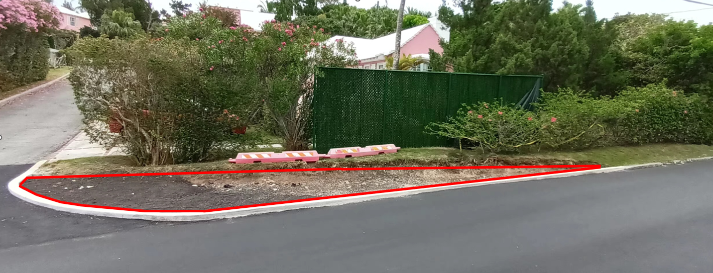
Area 1 – Young, The Ledgelets (260 SF)

Notes: Soil and grass to area marked in red. Remainder of Hibiscus hedge (highlighted with yellow oval) to be removed and entire length, from the southern boundary at the far right of the image to Ledgelets Lane, far left, to be planted with Olivewood; 3 gallon size at 12” (Marked with pink line). Please refer to drawings for more information.

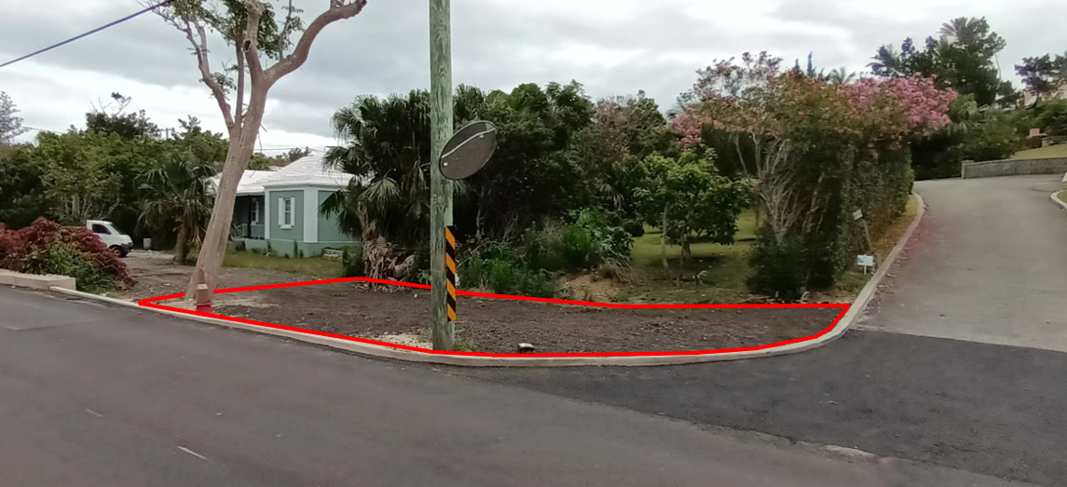
Area 2 – Young, The Ledgelets (1,470 SF)

Trash receptacle

Notes: Soil and grass to area marked in red. Pile of granular material to be graded and/or relocated (highlighted with yellow oval). North, South and Western boundaries to be planted with Light Pink Oleander; 3-gallon size at 12” (Marked with pink lines, leave 6’ gap for trash receptacle). Tree and 2x Chinese Fan Palms to be removed (marked with orange ovals). Please refer to drawings for more information.

Area 3 – Card, #119 Somerset Rd (6,050 SF) – Looking Northward
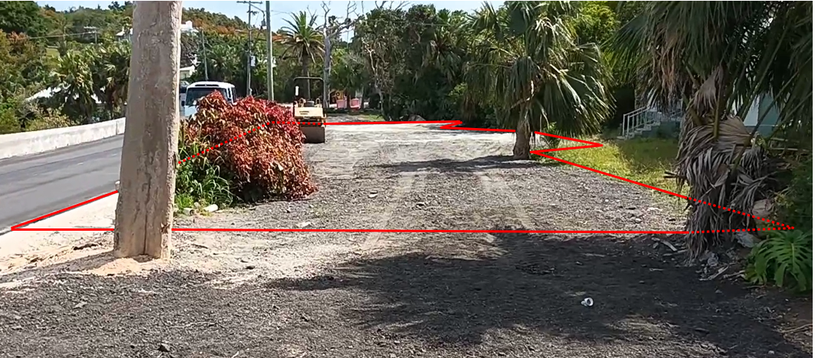
Notes: Soil and grass to area marked in red. Patches/holes/voids in Match-Me-If-You-Can hedgerow to be reinstated; 3 gallon size at 12”. Please refer to drawings for more information.

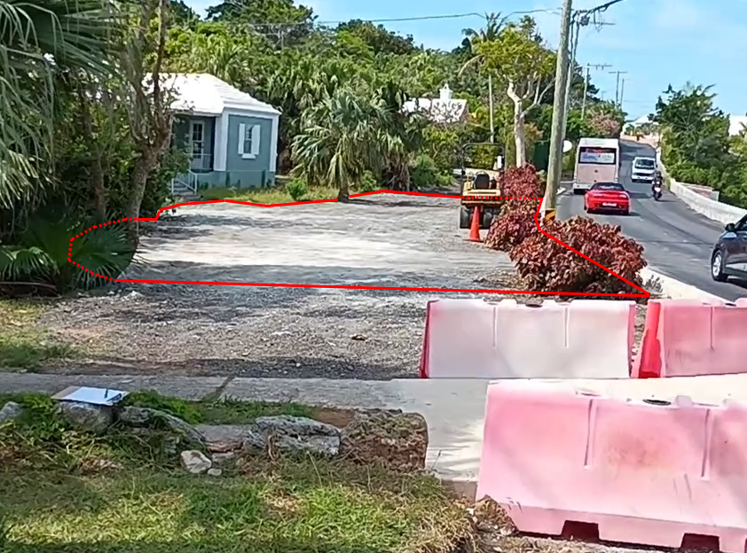
Area 3 – Card, #119 Somerset Rd – Looking Southward (Area noted above)

Notes: This is the same area as in the photograph above. Soil and grass to area marked in red. Patches/holes/voids in Match-Me-If-You-Can hedgerow to be reinstated; 3-gallon size at 12”. Boundary with #119 to be planted with Light Pink Oleander (marked with pink line, also noted in photo on the top of the next page). Please refer to drawings for more information.

Area 4 – Stones, #117 Somerset Rd. (780 SF)
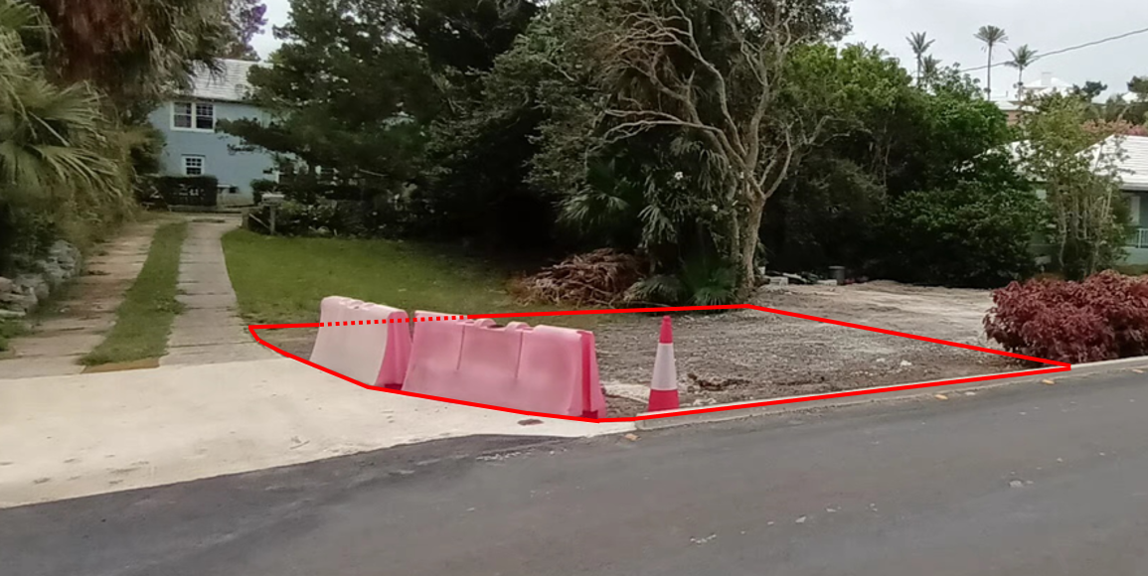

Notes: Soil and grass to area marked in red. Boundary with #119 to be planted with Light Pink Oleander; 3 gallon size at 12” (Marked with pink line, also noted in photo on bottom of previous page). Please refer to drawings for more information.

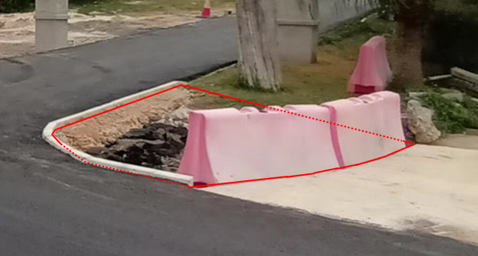
Area 4 – Stones, #117 Somerset Rd. (400 SF)

Notes: Soil and grass to area marked in red. This is the same property as in the photo above, the areas are located either side of the driveway.

Area 5 – Duperreault, #54 Railway Trail (2,200 SF)
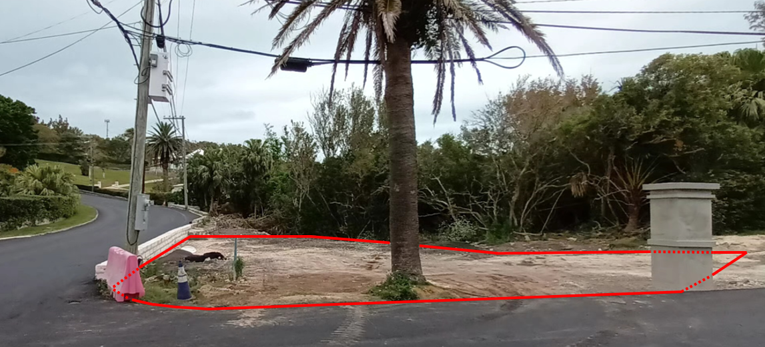

Notes: Soil and grass to area marked in red. 4x Bermuda Cedar trees, 3 gal. size. Please refer to drawings for more information.

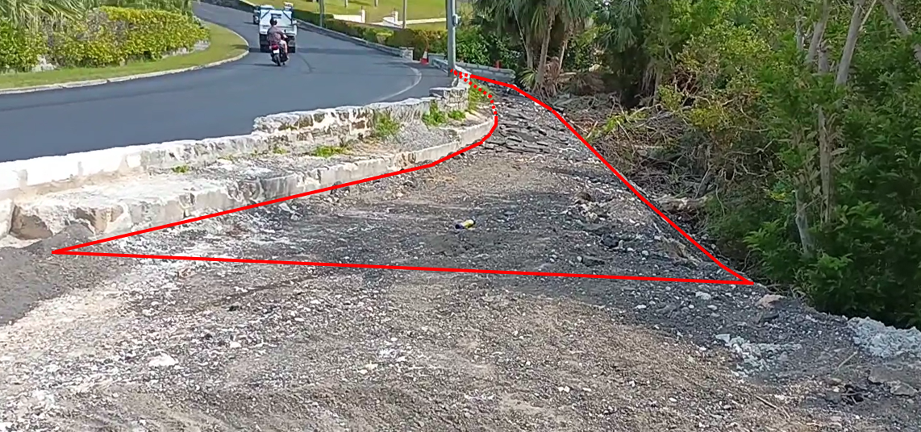
Area 6 – Duperreault, #54 Railway Trail (1,600 SF)

Notes: *Mulch* (i.e. not soil and grass) to area marked in red. Please refer to drawings for more information.

